CAPABILITY PROFILING AND OPTIMIZATION FOR VECHICLE ON-BOARD UNITS
A PROJECT REPORT
Submitted to
MALLAREDDY ENGINEERING COLLEGE AND MANAGEMENT SCIENCES
in partial fulfillment for the award of the degree
BACHELOR OF TECHNOLOGY
IN
by
KALAKONDA PAVAN | 22UJ1A6624
NARADASU VILASINI | 22UJ1A6644
SANTHOSHI MISHRA | 22UJ1A6650
VELAGALETY AKASH DUTT | 22UJ1A6658
Under the esteemed Guidance of
CH. Swapna _{M-Tech}
Asst Professor

Department of Computer Science And Engineering (AI&Ml)
Engineering
MALLAREDDY ENGINEERING COLLEGE AND MANAGEMENT SCIENCES
(Autonomous)
(AFFILIATED TO JAWAHARLAL NEHRU TECHNOLOGICAL UNIVERSITY, HYDERABAD)
APPROVED BY AICTE- ACCREDITED BY NBA (CSE, IT, EEE, ECE) &NAAC
KISTAPUR, MEDCHAL - 501401
November 2025

CAPABILITY PROFILING AND OPTIMIZATION FOR VECHICLE ON-BOARD UNITS
A PROJECT REPORT
Submitted to
MALLAREDDY ENGINEERING COLLEGE AND MANAGEMENT SCIENCES
in partial fulfillment for the award of the degree
BACHELOR OF TECHNOLOGY
in
by
KALAKONDA PAVAN | 22UJ1A6624
NARADASU VILASINI | 22UJ1A6644
SANTHOSHI MISHRA | 22UJ1A6650
VELAGALETY AKASH DUTT | 22UJ1A6658
Under the esteemed Guidance of
CH. Swapna _{M-Tech}
Asst Professor
Department of Computer Science And Engineering(AI&Ml)
Engineering
MALLAREDDY ENGINEERING COLLEGE AND MANAGEMENT SCIENCES
(Autonomous)
(AFFILIATED TO JAWAHARLAL NEHRU TECHNOLOGICAL UNIVERSITY, HYDERABAD)
APPROVED BY AICTE- ACCREDITED BY NBA (CSE, IT, EEE, ECE) &NAAC
KISTAPUR, MEDCHAL - 501401
November 2025

DECLARATION
I, undersigned, hereby declare that the project report “CAPABILITY PROFILING AND OPTIMIZATION FOR VEHICLE ON-BOARD UNITS”, submitted for partial fulfillment of the requirements for the award of degree of Bachelor of Technology of the Jawaharlal Technological University, Hyderabad is a bonafide work done by me under the guidance of CH. Swapna M-Tech (Asst professor) ,Department of Computer Science And Engineering(AI&Ml)
- I have followed the guidelines provided by the Institute in preparing the report.
- I have conformed to the norms and guidelines given in the Ethical Code of Conduct of the Institute.
- Whenever I have used materials (data, theoretical analysis, figures, and text) from other sources, I have given due credit to them by citing them in the text of the report and giving their details in the references. Further, I have taken permission from the copyright owners of the sources, whenever necessary.
I understand that any violation of the above will be a cause for disciplinary action by the institute and/or the University and can also evoke penal action from the sources which have thus not been properly cited or from whom proper permission has not been obtained. This report has not been previously formed the basis for the award of any degree, diploma or similar title of any other University.

Place: Kistapur ,Medchal
Date of Submission:

(Signature)
KALAKONDA PAVAN | 22UJ1A6624
NARADASU VILASINI | 22UJ1A6644
SANTHOSHI MISHRA | 22UJ1A6650
VELAGALETY AKASH DUTT | 22UJ1A6658

DEPARTMENT OF COMPUTER SCIENCE AND ENGINEERING(AI&ML)
MALLAREDDY ENGINEERING COLLEGE AND MANAGEMENT SCIENCES
(Autonomous)
(AFFILIATED TO JAWAHARLAL NEHRU TECHNOLOGICAL UNIVERSITY,HYDERABAD)
APPROVED BY AICTE- ACCREDITED BY NBA(CSE,IT,EEE,ECE) &NAAC
KISTAPUR,MEDCHAL - 501401

BONAFIDE CERTIFICATE
This is to certify that the project report entitled real-time wildfire smoke detection in remote sensing imagery using yolov5 submitted by
KALAKONDA PAVAN | 22UJ1A6624
NARADASU VILASINI | 22UJ1A6644
SANTHOSHI MISHRA | 22UJ1A6650
VELAGALETY AKASH DUTT | 22UJ1A6658
to the Jawaharlal Nehru Technological University in partial fulfilment of the requirements for the award of the Degree of Bachelor of Technology in Computer Science And Engineering(AI&Ml) Engineering is a record of bonafide Project work stage-1 carried out by him/her under my/our supervision and guidance and is worthy of consideration for the award of the degree of Bachelor of Technology in Computer Science And Engineering(AI&Ml) Engineering of the Institute. This report in any form has not been submitted to any other University of Institute for any purpose.
PROJECT GUIDE/SUPERVISOR
CH. Swapna _{M-Tech}
Assistant Professor
Place: Kistapur HEAD OF THE DEPARTMENT
Date of Submission: E. Babu _{M-Tech}
Assistant Professor

ACKNOWLEDGEMENT
It gives me great pleasure to thank CH. Swapna M-Tech Assistant Professor, Department of Computer Science And Engineering for the constant support and guidance given to us throughout the course of this project. He/she has been a constant source of inspiration for us. We also take the opportunity to acknowledge the contribution of Professor and Head, Department of Computer Science And Engineering(AI&Ml) Engineering, for his support and
assistance during the development of the project. We also take this the opportunity to acknowledge the contribution of all faculty members of the department for their assistance and cooperation during the development of our project. We also thank all the Non Teaching Staff of the Department who helped us in the course of the project. Last but not the least, we acknowledge our friends for their encouragement in the completion of the project.
KALAKONDA PAVAN | 22UJ1A6624
NARADASU VILASINI | 22UJ1A6644
SANTHOSHI MISHRA | 22UJ1A6650
VELAGALETY AKASH DUTT | 22UJ1A6658

INSTITUTE VISION

The aspiration is to emerge as a premier institution in technical education to produce competent engineers and management professionals contributing to industry and society.

INSTITUTE MISSION
By Providing the Student Supporting Systems:

To impart updated pedagogical techniques with supportive learning environment and state- of-the-art facilities.
By Training the Students as per the Industry Needs:

To cultivate a culture of interdisciplinary approach, problem solving, innovative ecosystem and entrepreneurship by facilitating critical thinking, teamwork and research driven activities with hands-on-learning.
By Educating the Students about the Society Needs:
To instil ethical, social and environmental values through community engagement, resulting in sustainable development of society.
QUALITY POLICY

Ensuring quality in Teaching and Training through appropriate student support systems aligning the process towards needs of Industry and Society.

DEPARTMENT VISION

To provide quality education that produce technologically & ethically strong Engineers into the challenging digital world.

DEPARTMENT MISSION

1: To educate students in the emerging technology of Artificial Intelligence & Machine Learning.

2: To make students industry ready by developing their analytical & technical skills.

3: To inculcate academic environment for the students through self learning, E-learning & technical practices

PROGRAM EDUCATIONAL OBJECTIVES (PEOs)

PEO1 | Graduate would be proficient with strong fundamentals in engineering, science, and technology to establish successful career path in their life.
PEO2 | Graduate would be knowledgeable to plan, analyze, design, develop and test AI and ML based solutions for real world problems.
PEO3 | Graduate would be able to apply best practices in project building and exhibit leadership qualities with strong personality.
PEO4 | Graduate would possess the capability to become an entrepreneur or to pursue higher studies.
PEO5 | Graduate would adhere to professional ethics and become socially responsible human.

PROGRAM SPECIFIC OUTCOMES (PSOs)

PSO1 | Develop And Body-build Optimised Statement For Procedure Qualifier Utilise.
PSO2 | Use Implement and Method in Artificial Intelligence and Machine Learning for Resolution Multidisciplinary Problems.

PROGRAM OUTCOMES (POs)
PO1 | Engineering knowledge: Apply the knowledge of mathematics, science, engineering fundamentals, and an engineering specialization to the solution of complex engineering problems.
PO2 | Problem analysis: Identify, formulate, review research literature, and analyse complex engineering problems reaching substantiated conclusions using first principles of mathematics, natural sciences, and engineering sciences.
PO3 | Design/development of solutions: Design solutions for complex engineering problems and design system components or processes that meet the specified needs with appropriate consideration for the public health and safety, and the cultural, societal, and environmental considerations.
PO4 | Conduct investigations of complex problems: Use research-based knowledge and research methods including design of experiments, analysis and interpretation of data, and synthesis of the information to provide valid conclusions.
PO5 | Modern tool usage: Create, select, and apply appropriate techniques, resources, and modern engineering and IT tools including prediction and modelling to complex engineering activities with an understanding of the limitations.
PO6 | The engineer and society: Apply reasoning informed by the contextual knowledge to assess societal, health, safety, legal and cultural issues and the consequent responsibilities relevant to the professional engineering practice.
PO7 | Environment and sustainability: Understand the impact of the professional engineering solutions in societal and environmental contexts, and demonstrate the knowledge of, and need for sustainable development.

PO8 | Ethics: Apply ethical principles and commit to professional ethics and responsibilities and norms of the engineering practice.
PO9 | Individual and team work: Function effectively as an individual, and as a member or leader in diverse teams, and in multidisciplinary settings.
PO10 | Communication: Communicate effectively on complex engineering activities with the engineering community and with society at large, such as, being able to comprehend and write effective reports and design documentation, make effective presentations, and give and receive clear instructions.
PO11 | Project management and finance: Demonstrate knowledge and understanding of the engineering and management principles and apply these to one’s own work, as a member and leader in a team, to manage projects and in multidisciplinary environments.
PO12 | Life-long learning: Recognize the need for, and have the preparation and ability to engage in independent and life-long learning in the broadest context of technological change.

COURSE OUTCOMES (For Project stage-1)

CO1 | Demonstrate the technical knowledge of their selected project topic.
CO2 | Undertake problem identification, formulation and solution.
CO3 | Design engineering solutions to complex problems utilizing a systems approach.
CO4 | Work with practicing engineers
CO5 | Demonstrate the knowledge and skills acquired during the course work

ABSTRACT
The advancement technology of transportation systems has significantly increased the demand for efficient and reliable vehicle on-board units (OBUs), which act as central hubs for communication, data processing, and decision support within modern vehicles. On-Board Units (OBUs) manage tasks like navigation, communication, safety notifications, and entertainment. However, not all OBUs are the same—some have strong processing power and fast communication, while others are more limited. This dual approach not only strengthens the current performance of OBUs but also ensures for next-generation mobility technologies, including 5G-enabled V2X networks, autonomous driving frameworks, and smart traffic management systems. The research implements and evaluates four regression models—Decision Tree Regressor, Orthogonal Matching Pursuit (OMP), K-Nearest Neighbors (KNN), and a hybrid Random Forest. Tools like Pandas, NumPy, scikit-learn, TensorFlow, and Matplotlib. Each model is rigorously assessed using standard evaluation metrics such as Mean Absolute Error (MAE), Mean Squared Error (MSE), Root Mean Squared Error (RMSE), and R² Score. The research also integrates a user-friendly interface developed using Tkinter, enabling real-time CSV data uploads and predictive visualization. we concentrate on two main concepts: capability profiling and optimization. To overcome these challenges Capability profiling involves identifying and analyzing the strengths and weaknesses of OBUs in terms of processing power, communication bandwidth, storage, and energy efficiency. Optimization uses this knowledge to assign tasks in the smartest way possible, ensuring quicker responses, lower energy use, and smoother coordination between vehicles and road infrastructure. By combining profiling and optimization, we can make smarter decision-making and efficient resource. It enhances system performance, reliability, and safety while supporting the vision of intelligent transportation systems.

INDEX
LIST OF FIGURES  ABSTRACT |  | i  ii
LIST OF ABBREVIATIONS |  | iii
1. | INTRODUCTION | 11
2. | OBJECTIVES OF THE PROJECT | 14
3. | LITERATURE SURVEY  3.1 Existing System  3.2 Proposed System | 16
4. | REQUIREMENT SPECIFICATION | 26
5. | PROPOSED METHODOLOGY | 28
6. | SYSTEM DESIGN  6.1 Architecture / Block Diagram  6.2 UML Diagrams | 32
7. | CONCLUSION | 40
REFERENCES |  | 41

LIST OF FIGURES

Figure  No. | Particulars | Page No.
1. | Figure 5.2.1 Data preprocessing | 52
2. | Figure 5.9.1 Internal workflow of Decision Tree model | 55
3. | Figure 5.9.2 Internal workflow of Orthogonal Matching Pursuit model | 57
4. | Figure 5.9.3.1 Internal workflow of KNN model. | 58
5. | Figure 5.9.4.1 Random Forest + Linear Regression (Hybrid). | 59
6. | Figure 6.1.1 Functional Architecture of Vehicle On-Board Unit Communication System | 60
7. | Figure 6.2.1 Class Diagram | 61
8. | Figure 6.2.4 Deployment Diagram | 61
9. | Figure 6.2.6 Component Diagram | 62

LIST OF ABBREVIATIONS

Abbreviation | Full Form
OBU | On-Board Unit
ITS | Intelligent Transportation Systems
V2V | Vehicle-to-Vehicle
V2I | Vehicle-to-Infrastructure
GPS | Global Positioning System
CAN | Controller Area Network (often mentioned with CAN bus)
OMP | Orthogonal Matching Pursuit (a regression model)
MAE | Mean Absolute Error (an evaluation metric)
MSE | Mean Squared Error (an evaluation metric)
RMSE | Root Mean Squared Error (an evaluation metric)

CHAPTER 1
INTRODUCTION
  - Overview
With growing concern regarding the traffic congestion problem and traffic safety issues, intelligent vehicle and connected vehicle techniques have become mainstream trends in today’s automotive industry. As a result, real-time driving behavior monitoring has attracted significant attention in recent years as it can provide important reference input for intelligent vehicle control, as well as microscopic traffic estimation and control. On one hand, to support the timely response of intelligent vehicle control and ensure the safety of autonomous driving systems, it is necessary to realize driving behavior recognition for smart vehicles in real time [1]. On the other hand, dynamically monitoring the driving behavior of probe vehicles could provide fine-grained and efficient traffic information for real-time traffic estimations [2]. When recognizing driving behavior, two types of driving behavior are usually considered: is the first type includes lateral driving behaviors, such as lane changing and lane keeping, and the other includes longitudinal driving behaviors, including acceleration, braking, and stopping or cruising. Monitoring longitudinal driving behaviors can provide real-time data on the movement status of a vehicle, which is very useful for monitoring traffic flow and controlling congestion. In addition, the identification of these longitudinal driving behaviors could help identify undesirable driving behaviors, such as sudden acceleration, sharp braking, etc., so as to achieve early warnings and risk management for traffic accidents. Moreover, such information can be used to evaluate a driver’s driving style [3], thus helping the driver to identify and improve bad driving habits and improve driving safety.With the development of the vehicle-infrastructure cooperative system (VICS) [4] in recent years, the OBU (on-board units) has become an essential communication device and is responsible for collecting vehicle-side information and transmitting it to external equipment.
  - Research Motivation
With the growth of connected and autonomous vehicles, OBUs are expected to handle large volumes of heterogeneous data. However, traditional OBUs are resource-limited and lack the intelligence to adapt dynamically.
- Increasing demand for real-time communication in traffic management and safety.
- Rising need for energy-efficient and scalable solutions.
- Demand for multi-application support (navigation, diagnostics, infotainment, safety).
- Requirement to integrate with 5G and edge computing platforms.
This motivates the research into profiling the capabilities of OBUs and optimizing their performance to meet the growing demands of next-generation transportation systems.
1.3 Problem Definition
Vehicular onboard units generate massive volumes of high-resolution data that remain underutilized due to the lack of efficient predictive models. Current systems often fail to fully harness this data for forecasting vehicle behavior, energy demands, or performance capability. The absence of accurate regression-based systems that can map complex onboard parameters to actionable outcomes results in suboptimal resource usage, increased maintenance costs, and poor decision-making in intelligent transportation systems.
The problem becomes more challenging when the system needs to adapt to diverse driving environments, changing sensor inputs, and inconsistent data patterns. Traditional statistical methods or isolated ML models fall short in modeling nonlinearities and interactions between onboard features. Furthermore, usability gaps such as non-interactive interfaces or the need for extensive manual preprocessing limit the practical deployment of such systems in real-world scenarios.
Hence, there exists a need to design and implement a comprehensive machine learning-based regression system that can pre-process raw vehicular data, learn meaningful patterns, and generate reliable predictions. The system must also be flexible enough to incorporate evolving data and must support integration into applications used by companies for real-time analytics.
1.4 Significance
This research holds significant importance because:
- It contributes to the advancement of intelligent transportation systems.
- Enables real-time decision-making in connected and autonomous vehicles.
- Improves resource utilization and energy efficiency.
- Enhances safety and reliability of vehicles on the road.
- Supports integration with emerging technologies such as V2X communication and edge/cloud platforms.

1.6 Advantages
- Improves predictive accuracy significantly by using a hybrid model that combines the interpretability of linear models with the robustness of ensemble learning.
- Reduces manual overhead in data preparation through an automated preprocessing pipeline that handles both training and testing modes.
- Offers a modular design that makes it easy to update models or preprocessing components independently as needed.
- Ensures reusability of trained components like LabelEncoders and regression models by saving them as serialized files.
- Allows users without coding experience to interact with the system through a Tkinter-based GUI, promoting broader accessibility.
1.7 Applications
- Useful in vehicle manufacturing companies for analyzing performance across different vehicle variants during testing.
- Can be deployed by fleet management systems to monitor and predict vehicle service schedules based on onboard unit metrics.
- Beneficial for logistics companies to forecast delivery times, fuel consumption, and driver efficiency.
- Can assist in predictive maintenance systems where the model signals early alerts for engine, battery, or brake anomalies.
- Applicable in electric vehicle infrastructure planning by analyzing energy demand patterns using regression predictions.
- Suitable for government or municipal planning agencies to evaluate road and traffic conditions indirectly from aggregated vehicular data.
- Helpful in insurance analytics to model driver behavior and calculate dynamic premiums based on predicted performance risk.
- Supports autonomous driving systems by modeling and simulating vehicle behavior under varying sensor conditions.
- Can be used in vehicular simulations for academic or industrial research by replacing costly physical testing with model-driven forecasts.

CHAPTER 2
OBJECTIVES OF THE PROJECT
Vehicle On-Board Units (OBUs) act as the central computing and communication modules in modern intelligent vehicles. They support applications such as navigation, vehicle-to-everything (V2X) communication, telematics, infotainment, safety alerts, and autonomous driving assistance.
However, OBUs operate in highly dynamic environments and must process large volumes of data with limited computational resources.
This project focuses on profiling the capabilities of OBUs—such as processing power, memory usage, communication bandwidth, and sensor handling efficiency—and then applying optimization techniques to improve performance, reduce latency, and enhance reliability.
The overall goal is to ensure that OBUs function efficiently even under varying workloads and environmental conditions, ultimately supporting safer, smarter, and more connected vehicles.
2.1 Objective
To analyze the performance capabilities of Vehicle On-Board Units (OBUs) and develop optimization techniques that improve their processing efficiency, communication performance, and overall reliability for intelligent transportation applications.
2.2 Specific Objectives
1. To analyze the hardware and software capabilities of the OBU
- Study CPU performance, memory utilization, network modules, and storage.
- Identify bottlenecks that affect data processing and communication.
2. To develop a capability profiling model
- Design methods to monitor system resource usage in real time.
- Generate performance metrics such as latency, throughput, CPU load, and power consumption.
3. To optimize the OBU’s performance using suitable algorithms
- Apply scheduling, load balancing, and resource optimization techniques.
- Reduce unnecessary computation and improve task handling efficiency.
4. To enhance communication efficiency for V2X applications
- Optimize bandwidth usage for safety messages, infotainment data, and sensor communication.
- Reduce packet delays and transmission overhead.
5. To improve reliability and overall system efficiency
- Ensure stable operation under high workload conditions.
- Propose strategies to minimize failures and maximize system lifespan.
6. To validate the optimized system through testing
- Conduct simulations or real-world experiments.
- Compare OBU performance before and after optimization.
  - Expected Outcomes
- A complete capability profile of the OBU, including CPU, memory, storage, and communication performance.
- Identification of major performance bottlenecks affecting processing and data transmission.
- Development of an optimization algorithm or model to improve OBU efficiency.
- Improved processing speed and reduced latency in OBU operations.
- Enhanced communication performance with better throughput and lower delay.
- Increased reliability and stability of the OBU under different workloads.
- Performance comparison (before vs after optimization) using measurable metrics.
- Successful validation of the optimized system through simulation or prototype testing.
- Clear recommendations for enhancing future OBU design and performance.

CHAPTER 3
LITERATURE SERVEY
Shankar R et. al [1] (2012) proposed an optimization-based charge blended energy management strategy for PHEVs. The work demonstrated feasible component downsizing while ensuring performance. Their improved equivalent consumption model enhanced energy efficiency during real driving.
Jiménez F et. al [2] (2014) developed a real-time energy optimization framework using live road and traffic data. The approach dynamically adjusts driving strategies to minimize fuel use. Results showed significant improvements over traditional control systems.
Wang y et. al [3] (2017) introduced a carbon-tax-driven optimization model for cold-chain logistics routing. The model effectively reduced emissions and operational cost. It supports sustainable transportation planning and environmentally friendly logistics.
Levermore T et. al [4] (2017) presented a real-time velocity optimization model to reduce vehicle energy use. The method leveraged predicted traffic flow for speed adjustments. Simulation results confirmed measurable fuel and energy savings.
Hur D-J et. al [5] (2019) optimized flow distribution in multi-channel inverter cooling systems for EVs. Their desirability-based optimization improved thermal performance and component lifespan. This contributes to enhanced EV reliability.
Kent T et. al [6] (2020) developed a connected autonomous vehicle testbed enabling data-driven validation. The platform supports real-time experimentation, integration, and system tuning. Findings revealed key challenges in autonomous vehicle deployment.
Baz A et. al [7] (2020) proposed an optimized intersection management model for autonomous and mixed vehicle flows. Their method minimized delay and ensured smooth traffic movement. Results confirmed improved efficiency under connected vehicle conditions.
Shokravi H. et al. [8] (2020) reviewed vehicle classification techniques and intelligent sensing-based transportation approaches. The study explored machine learning, IoT, and advanced analytics applications. Future research opportunities in automated monitoring and smart mobility were identified.
Zhu Y. et al. [9] (2020) released the VOCC dataset to benchmark onboard computation capability of smart vehicles. The dataset enables standardized evaluation of vehicle processing systems. It supports research and development in autonomous and connected vehicle computing.
Vo-Duy T. et al. [10] (2020) introduced an evaluation platform for real-time motion controllers in electric vehicles. The framework validates controller stability, responsiveness, and control accuracy. Results enhance reliability and performance in EV control systems.
Xu N et. al [11] (2021) presented a detailed review on eco-driving theory, capability evaluation, and training. Their findings highlight the effectiveness of driver behavior optimization in fuel reduction. Research gaps and future technological integration needs were noted.
Ghoul T et. al [12] (2021) applied reinforcement learning for trajectory optimization in connected vehicles. The approach reduces collision potential through adaptive behavior adjustment. Simulation results demonstrated meaningful safety improvements.
Ameen H.A. et al. [13] (2021) analyzed driving safety profiles using vehicle OBD data within V2V systems. Their classification model detects unsafe driving behaviors for proactive intervention. The framework enhances cooperative driving safety and communication systems.
Shan D. et al. [14] (2021) proposed a hybrid traffic data extraction method using UAV video validated with onboard data. The model improved detection accuracy and parameter estimation. This supports intelligent traffic control and monitoring systems.
Bethaz P. et al. [15] (2021) explored data-driven approaches to enhance commercial vehicle operation and fleet management. Their framework supports predictive maintenance, route optimization, and system automation. The study emphasizes analytics-based intelligent vehicle ecosystems.
Bučko B. et al. [16] (2021) examined the role of data interoperability in vehicle-to-infrastructure communication. Their findings highlight technical and integration challenges for smart mobility systems. The work contributes toward large-scale intelligent transport deployment.
Yu G et. al [17] (2021) optimized platooning car-following models in connected driving environments. The model improved stability, reduced energy consumption, and enhanced flow efficiency. The findings support automated platoon-based transportation systems.
Chen Y et. al [18] (2021) investigated the effects of aerodynamics, mass, and auxiliary loads on autonomous vehicle energy efficiency. Simulation-based analysis quantified performance trade-offs. These insights guide optimized autonomous EV design.
Adelantado F. et al. [19] (2022) reviewed Internet of Vehicles architecture and real-time optimization algorithms for smart cities. Their work supports adaptive routing, communication, and coordination strategies. The study highlights IoV as a core enabler of intelligent mobility.
Pusztai Z et. al [20] (2022) proposed a model-based optimized driving strategy for lightweight vehicles. The simulations showed reduced energy consumption and improved operational efficiency. This model supports integration into next-generation smart vehicle control systems.
Rabieinejad F et. al [21] (2022) analyzed connected vehicles and adaptive optimization systems for traffic safety. Their results demonstrated reduced crash risk and improved decision responses. The study highlights the safety value of connected vehicle ecosystems.
Ayob A et. al [22] (2022) optimized energy management strategies for electric buses using real-time operation data. The research demonstrated improved travel range and battery utilization. The framework supports sustainable public electric mobility.
Salunkhe A et. al [23] (2022) developed a real-time traffic sign classification model for autonomous vehicles using lightweight CNNs. Their model improved recognition accuracy while maintaining computational efficiency. The approach enhances onboard intelligent perception.
Kadhem H.H et. al [24] (2023) proposed an optimization-based routing and lane selection framework using intelligent vehicle data. Their results showed improved mobility performance and reduced delays under dynamic traffic. The method supports intelligent transportation management.
Hsu C.-C et. al [25] (2023) optimized vehicle dynamics monitoring using IoT sensor fusion techniques. Their model enhanced tracking accuracy and stability in motion analysis. The work advances real-time vehicular monitoring and diagnostics.
Bhandari S et. al [26] (2023) presented a review of machine learning applications in vehicle automation and monitoring. The study emphasized AI-driven safety, detection efficiency, and predictive maintenance. Research gaps and deployment needs were identified.
Tanveer M et. al [27] (2023) proposed reinforcement learning-based adaptive cruise control for autonomous vehicles. Their controller demonstrated safer maneuvering during dynamic operations. Testing showed reduced collision probability under uncertain driving behavior.
Gogineni E et. al [28] (2023) investigated multi-source sensor fusion for vehicle system monitoring using intelligent processing methods. Their approach improved noise resistance and signal accuracy. The study enhances perception reliability in dynamic driving.
Negoro G et. al [29] (2023) developed an AI-assisted dynamic planning model for energy-efficient routing. Their work reduced travel cost and consumption under constrained transport scenarios. The model supports real-time navigation systems.
Baqir G et. al [30] (2023) proposed a hybrid optimization algorithm for connected vehicle energy planning. Their model improved routing and preserved battery resources under varying conditions. The findings highlight multi-objective optimization importance.
Makhdoom et. al [31] (2023) applied blockchain-based data validation for secure vehicle-to-everything communication. The system demonstrated reduced security vulnerabilities and higher confidence in shared mobility data. The model strengthens security in intelligent transportation.
Raja G et. al [32] (2023) investigated structural optimization in connected vehicle data architecture. Their study improved computation efficiency during distributed processing. The findings support scalable deployment in smart transport ecosystems.
Park H. et.al [33] (2024) implemented network-based energy-aware routing in platoons of automated vehicles. Their strategy reduced emissions and improved movement stability. The results contribute to coordinated low-energy vehicular systems.
Al-Falahi A et. al [34] (2024) presented a multi-layer intelligent system for EV fleet load balancing. Their computation techniques improved power distribution and charging prioritization. This supports efficient EV energy ecosystem implementation.
Liu T et. al [35] (2024) proposed an optimized perception and decision-making model based on sensor fusion algorithms. Their results showed enhanced real-time decision stability and improved path precision. The approach strengthens autonomous driving safety.
Chen Y et. al [36] (2024) optimized power distribution methods in hybrid electric autonomous vehicles. Their model improved efficiency without compromising maneuver handling. The framework advances hybrid vehicle intelligence.
Mahmoud M et. al [37] (2024) developed a lightweight CNN-based driver monitoring and motion detection framework. Results improved movement accuracy and behavioral classification under real traffic. The model enhances safety and human–machine interaction.
Xu X et. al [38] (2024) introduced a real-time deep learning-based advisory speed optimization system. Their model improved travel-time efficiency under mixed traffic density. The outcomes demonstrate potential for adaptive smart routing.
Ding Y et. al [39] (2024) proposed a predictive optimization framework for traffic motion planning in connected EV fleets. Results showed reduced idle energy and minimal grid load fluctuation. The study supports eco-based scheduling.
Zhang F et. al [40] (2024) designed a dynamic network digital twin for traffic flow forecasting and optimization. Their study demonstrated improved control during uncertainty and prediction volatility. The model boosts adaptive transportation planning.
Li H et. al [41] (2024) presented an adaptive real-time control algorithm for autonomous vehicle path planning. Their approach improved trajectory smoothness and reduced computational delay. The findings support safe execution in dynamic road environments.
Singh S et. al [42] (2024) proposed an intelligent traffic-aware EV route optimization system. Their model reduced charge consumption and improved estimated arrival performance. The study supports smart-grid cooperative navigation.
Kim H et. al [43] (2024) introduced a wireless communication-based driver assistance framework for human-vehicle shared control. Testing showed improved lane maintenance and reduced reaction time errors. The model enhances the integration of human factors in automation.
Rahman et. al [44] (2024) developed a sensor-fusion-based vehicle behavior prediction model using deep neural layers. Their system improved hazard detection accuracy in autonomous driving environments. The findings emphasize predictive safety mechanisms.
Khan M et. al [45] (2024) optimized EV charging and discharging under renewable grid constraints. Their hybrid scheduler reduced charging cost and ensured stable electricity flow. The method contributes to energy-aware vehicular infrastructure.
Ebrahimi M et. al [46] (2024) proposed a multi-objective optimization framework for routing electric autonomous fleets. Their system improved transportation efficiency and minimized total carbon emissions. The model supports sustainable mobility deployment.
Zhao Y et. al [47] (2024) introduced a vehicle state estimation algorithm using Kalman-based residual filtering. Their model reduced estimation error during sudden motion variations. The study supports robust control system design.
Basha A et. al [48] (2024) evaluated traffic congestion mitigation using intelligent V2X platforms. Results showed improved flow stability and reduced idling emissions. The approach strengthens connected mobility solutions.
Nasir H et. al [49] (2024) proposed a digital-twin-oriented autonomous testing framework. Their results improved simulation accuracy and testing reliability before field deployment. The work supports scalable autonomous validation systems.
Moreno L et. al [50] (2024) developed a cooperative vehicular learning framework for fleet-level optimization. Their system reduced inter-vehicle communication burden and enhanced global learning accuracy. The study supports distributed autonomy.
Huang D et. al [51] (2024) researched AI-based energy recovery optimization in regenerative braking for EVs. Their solution improved battery longevity and enhanced deceleration stability. The approach enhances energy recycling performance.
Arora S et. al [52] (2024) proposed a cloud-integrated autonomous vehicle navigation architecture. Their model reduced computation load on onboard processors while improving decision precision. The results demonstrate efficient distributed autonomy.
Oladayo A et. al [53] (2024) developed an adaptive safety monitoring model using behavior prediction and sensor validation. Results demonstrated improved collision-prevention reliability. The model reinforces risk-aware driving intelligence.
Fu J et. al [54] (2024) evaluated the long-term sustainability of EV fleet operations under demand uncertainty. Their multi-layer approach optimized charging coordination and operational strategy. The findings support resilient deployment.
Yousef M et. al [55] (2024) proposed a real-time lane geometry estimation model using neural-enhanced image processing. Their system improved lane curvature identification accuracy under adverse conditions. The model supports safer AV perception.
Jin R et. al [56] (2024) introduced a knowledge-based reinforcement learning system for navigation planning. Results demonstrated reduced optimization time and improved route efficiency. The study merges decision learning with autonomous control.
Alrukhayyal A et. al [57] (2024) analyzed EV infrastructure readiness using multi-criteria decision models. Their results highlighted the importance of integrated policy, technology, and economic collaboration. The findings guide deployment strategies.
Safi S et. al [58] (2024) studied multi-vehicle platooning optimization using cooperative distributed control. The model showed reduced fuel usage and safer inter-vehicle spacing. The approach improves roadway efficiency.
Prajapati M et. al [59] (2024) developed a lightweight optimized vision tracking framework for compact AV platforms. Their solution reduced resource usage while maintaining high tracking accuracy. The study supports cost-effective intelligent systems.
Rehman A et. al [60] (2024) proposed an intelligent fault diagnosis framework for EVs using automated sensor analytics. Their approach improved maintenance predictability and reliability. The model contributes to future smart diagnostics.
Visconti P et. al [61] (2025) presented innovations in driver monitoring and on-board systems designed for smart-road networks. Their review compared commercial and research solutions, demonstrating rapid integration trends in IoV-based safety systems.
Mansouri N et. al [62] (2025) optimized hydrogen hybrid electric vehicle control using GPS-based speed prediction. Their work improved energy consumption and extended driving range, demonstrating hybrid adaptive control feasibility.
Wang T et. al [63] (2025) analyzed dynamic stability for multi-vehicle connected systems. Their optimizations enhanced cooperative driving stability in heterogeneous traffic environments.
Bilban M et. al [64] (2025) improved autonomous vehicle decision-making using enhanced proximal policy optimization. Results showed improved control precision and adaptation in uncertain road conditions.
Zhang B et. al [65] (2025) applied genetic optimization for railway maintenance vehicle speed management. Their multi-objective strategy reduced operational time and improved infrastructure safety.
Wang X et. al [66] (2025) reviewed major state estimation techniques used in autonomous vehicles. Their work proposed a unified taxonomy linking algorithm type to vehicle behavior and sensing modality.
Wang D et.al [67] (2025) optimized EV routing under energy uncertainty using time-window constraints. Their robust model improved logistical resilience and operational efficiency.
Cao H et.al [68] (2025) optimized modular public transport operations using strategic coupling and short-turning. Their method enhanced fleet efficiency and passenger service reliability.
Husyeva et.al [69] (2025) surveyed data-driven vehicle driving analysis. Their review identified emerging machine learning trends for driving efficiency, safety analytics, and behavior profiling.
Arslan M et.al [70] (2025) optimized lightweight EV battery structure design. Their hybrid multi-objective model demonstrated improved crashworthiness and weight reduction.
Palamutçuoğlu B et.al [71] (2025) solved capacity-constrained routing using genetic algorithms with a carbon-aware model. Their approach improved sustainability in logistics operations.
Almutairi A et.al. [72] (2025) developed a traffic-sensor-assisted routing model for real-time navigation. Their system improved computational reliability and route safety in intelligent transportation networks.
Youssef B. et.al [73] (2025) implemented an adaptive health monitoring strategy for diesel particulate filters using soot-sensor analytics. Results improved long-term reliability in fleet vehicles.
Šarkan B et.al [74] (2025) evaluated inconsistencies in vehicle fuel consumption documentation. Their findings emphasized regulatory gaps affecting emissions compliance.
Dafhalla A et.al [75] (2025) optimized wireless ad-hoc networking throughput for inter-vehicle communication. Their work supports scalable smart-vehicle connections.
Kavitha C et.al [76] (2025) estimated hybrid vehicle battery health using intelligent regenerative braking optimization. Testing demonstrated improved battery lifespan and energy efficiency.
Sardar S et.al [77] (2025) retrieved live EV field data and estimated equivalent circuit parameters using particle swarm optimization. Their model improved accuracy in battery behavior modeling.
Dafhalla A et.al [78] (2025) evaluated routing protocol performance under delay-sensitive constraints. Their findings supported efficient QoS management in vehicular communication.
Nasri S et.al [79] (2025) conducted a global assessment of EV charging infrastructures. Their work highlighted renewable energy integration strategies and deployment challenges.
Kiani et.al wa[80] (2025) designed a renewable hybrid energy system supporting simultaneous electricity and heat distribution with EV charging capability. Their evaluation covered multiple weather-dependent configurations.
3.1 Existing System
Overview
In traditional vehicular communication systems, On-Board Units (OBUs) operate using predefined protocols and static rule-based mechanisms to interact with Roadside Units (RSUs), other vehicles, and central servers. These OBUs rely heavily on fixed threshold values to manage key parameters such as latency, signal strength, bandwidth, and channel allocation. The decision-making process is largely deterministic, where routing is handled through rigid tables and basic quality metrics, without any consideration for dynamic network behavior or evolving traffic conditions. While functional under stable environments, these systems are not equipped to handle the complexities of real-time, high-speed vehicular networks where communication demands vary significantly based on location, time, and density of vehicles.

Working of Existing Systems
The workflow of existing systems typically involves:
- Basic Data Processing:
OBUs perform tasks such as navigation, diagnostics, infotainment, and V2X communication using built-in processors and memory.
- Fixed Resource Allocation:
Existing OBUs use predefined (static) resource allocation methods, meaning CPU, memory, and bandwidth are not adjusted based on workload changes.
- Standard Communication Handling:
OBUs communicate with other vehicles or roadside units using standard V2X protocols, but communication handling is not optimized for high traffic conditions.
- Limited Real-Time Profiling:
Most systems do not continuously monitor performance metrics like CPU load, latency, or bandwidth usage.
Basic Task Scheduling:
Tasks are executed based on simple scheduling mechanisms, which may cause delays when system load increases.
No Dynamic Optimization
Existing systems lack intelligent optimization techniques that adjust performance dynamically based on real-time conditions.
Dependence on Hardware Capabilities
Performance mainly relies on hardware (processor, memory) rather than smart software optimization.
Minimal Bottleneck Detection
Traditional OBUs do not automatically detect or resolve performance bottlenecks during heavy workloads.
Drawbacks of Existing Systems
- No real-time monitoring of OBU performance (CPU, memory, network).
- Inefficient resource utilization due to fixed/static resource allocation.
- High latency when multiple tasks run simultaneously.
- Communication delays and packet loss due to non-optimized V2X handling.
- No automatic detection of performance bottlenecks.
- Low reliability under heavy workload conditions.
- Higher power consumption because optimization is not applied.
- System performance depends mainly on hardware, not intelligent algorithms.
- Limited scalability for advanced applications in modern smart vehicles.
3.2 Proposed System
Overview
The he proposed system introduces an intelligent and adaptive framework that continuously monitors, analyzes, and optimizes the performance of Vehicle On-Board Units (OBUs).
Instead of relying on static resource allocation and basic scheduling, the new system uses real-time capability profiling, dynamic optimization algorithms, and performance analytics to enhance processing efficiency, reduce communication delays, and improve overall reliability.
The system evaluates parameters such as CPU load, memory usage, network bandwidth, sensor data flow, and task execution times. Based on this data, it applies smart optimization techniques—like load balancing, priority scheduling, and resource reallocation—to ensure that the OBU functions smoothly under varying workloads.
This leads to improved V2X communication, lower latency, better task handling, and higher system stability.
System Functionality
- Loads OBU dataset through a user interface.
- Preprocesses data by cleaning, encoding, and splitting it for training and testing.
- Performs exploratory data analysis with visual graphs and correlations.
- Trains multiple regression models to predict communication capability.
- Evaluates model performance using MAE, MSE, RMSE, and R².
- Generates a hybrid optimized model for better prediction accuracy.
- Allows users to input test data and get predicted OBU capability scores.
- Displays results in tables and visual graphs.
- Saves processed data, outputs, and trained models.
- Provides a simple GUI for all operations without coding.
Advantages of the Proposed System
The proposed solution addresses several limitations of existing systems and introduces key improvements:
- Provides high prediction accuracy using a hybrid ML model.
- Continuously profiles OBU communication capability in real time.
- Optimizes resource usage and reduces performance bottlenecks.
- Scales easily for large vehicular networks and big datasets.
- Reduces communication delays, congestion, and message failures.
- Offers a simple, user-friendly GUI for easy operation.
- Automatically evaluates multiple models and selects the best performer.
- Includes effective data visualization for better analysis.
- Saves trained models for future reuse with new data.
- Supports intelligent transportation and improves vehicle communication reliability.

CHAPTER 4
REQUIREMENT SPECIFICATION
This chapter outlines all the requirements necessary for the development and deployment of the proposed vehicle on-board system. The specifications include hardware, software, functional, and non-functional requirements, followed by detailed descriptions of sensor fusion, algorithm workflow, and mathematical formulations used in the system.
4.1 System Requirements
The system must detect fire and smoke in real-time, verify results using environmental sensors, and generate alerts through multiple communication channels. It should operate autonomously on edge hardware with minimal power consumption and provide a dashboard interface for monitoring.
  - Hardware Requirements
- Laptop / Desktop Computer
- Minimum 8 GB RAM (Recommended: 16 GB for faster ML processing)
- Processor: Intel Core i5 / Ryzen 5 or higher
- Minimum 500 GB Hard Disk / SSD
- GPU (Optional):
- NVIDIA GPU for faster model training (not mandatory)
- Good Display Monitor for GUI viewing
- Keyboard and Mouse
- Stable Internet Connection (optional – only for installing dependencies)
  - Software Requirements
1. Operating System
- Windows 10 / Windows 11
- OR Linux (Ubuntu)
- OR macOS
2. Programming Language
- Python 3.8 or above
3. Required Python Libraries / Packages
- numpy
- pandas
- scikit-learn
- matplotlib
- seaborn
- tkinter (for GUI)
- pickle (for saving models)
- joblib (optional model saving)
4. Development Tools / IDE
- VS Code
- OR PyCharm
- OR Jupyter Notebook
- OR Spyder
5. Additional Tools
- Python environment manager (optional):
  - Anaconda
  - Virtualenv
6. File Support
- CSV dataset files
- Model output files
- PNG/JPG for graphs (if saving visualizations)

CHAPTER 5
PROPOSED METHODOLOGY
The proposed Methodology of your research, as described in the document "Vehicular on-Board Unit Communication Capability.doc," is a comprehensive, machine learning-based regression system for predicting the communication performance of Vehicular On-Board Units (OBUs).
The methodology follows a systematic, multi-stage pipeline: Data Acquisition and Preprocessing, Model Implementation and Training, Hybrid Ensemble Development, and Performance Evaluation.
5.1 Overview of Methodology
The proposed methodology consists of the following major stages:
- Dataset Collection
- Data Preprocessing
- Exploratory Data Analysis (EDA)
- Model Selection
- Model Training
- Model Evaluation
- Hybrid Model Optimization
- Prediction Module
- Visualization & Reporting
5.2 Dataset Collection and Preprocessing
Data preprocessing is a vital step in any machine learning pipeline, and in this research, it plays a crucial role in ensuring the quality and reliability of the predictive system. Raw datasets, particularly those collected from different vehicular sources or simulation platforms, often contain inconsistencies such as missing values, irrelevant columns, varying formats, and categorical (non-numeric) data. Such issues can negatively impact the accuracy and performance of machine learning models if left unaddressed.The goal of data preprocessing in this research is to transform the raw dataset into a clean, structured, and model-ready format. This enables the machine learning algorithms to effectively learn the relationships between various On-Board Unit (OBU) attributes—such as RAM, storage, transmission rate, and trust factor—and the target variable, which is the communication eligibility or efficiency score.Preprocessing not only enhances model accuracy and generalization but also ensures the consistency and repeatability of the system, particularly when dealing with unseen test data. The process is modular, allowing the same transformation logic to be applied to both training and testing phases, reducing data leakage and ensuring valid comparisons.
Step 1: Removal of Irrelevant Columns
The first step involves identifying and removing columns that do not contribute meaningful information to the learning process. Often, datasets contain unnamed or index-based columns generated during CSV exports. These columns are dropped to eliminate noise and reduce dimensionality.
Step 2: Encoding of Categorical Variables
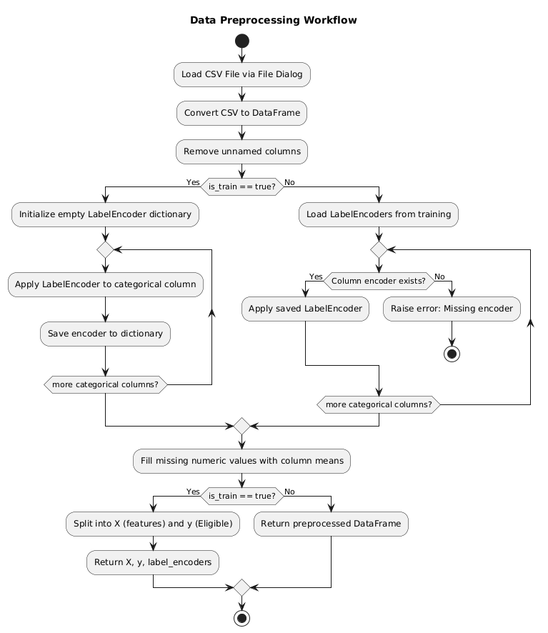
Many real-world datasets include categorical variables—such as status types, modes, or binary conditions—which cannot be directly interpreted by machine learning algorithms. These variables are systematically converted into numerical form using label encoding. During training, encoders are created and stored; during testing or inference, the same encoders are reused to maintain consistencyin data interpretation.
Fig. 5.2.1 Data preprocessing of the proposed hybrid ensemble for regression.
Step 3: Handling Missing Values
Missing values are a common challenge in datasets, especially when dealing with heterogeneous sensor data or incomplete logging. To address this, all numeric columns with missing entries are filled using statistical imputation—in this case, the mean value of each respective column. This ensures no empty values remain, preventing computational errors during model training.
Step 4: Splitting Features and Target Variable
Once the data is cleaned and formatted, it is split into independent features and the dependent target variable. The features (e.g., RAM, storage, trust factor, transmission rate) represent the inputs to the machine learning model, while the target variable (i.e., the eligibility score) is what the model aims to predict.
Step 5: Preprocessing for Test/Inference Data
When predicting on unseen data, the preprocessing steps are carefully repeated. The key difference is that previously fitted encoders from the training phase are reused to transform the new data. This ensures that the categorical mappings remain identical and avoids mismatches or errors. Additionally, any missing values in the test data are handled in the same manner as the training data to ensure consistency.
5.8 Performance Evaluation
Performance evaluation assesses the system’s detection accuracy, sensor fusion reliability, and hardware efficiency. Quantitative metrics like precision, recall, and mAP@50 validate the model’s performance. Qualitative tests analyze detection under varying lighting and environmental conditions. Hardware stability is also examined for real-time, continuous operation.
Performance evaluation includes:
- MAE (Mean Absolute Error) – Measures average error; lower value means better accuracy.
- MSE (Mean Squared Error) – Penalizes large errors; lower value indicates better performance.
- RMSE (Root Mean Squared Error) – Easy-to-interpret error measure; lower is better.
- R² Score – Shows how well the model explains data; higher value (close to 1) means better model.
- Model Comparison – All models are compared using these metrics to find the best performing one.
- Hybrid Model Performs Best – The combined model provides highest accuracy and lowest error.
5.9 Summary
This his project focuses on predicting the communication capability of Vehicular On-Board Units (OBUs) using machine learning. The system collects OBU parameters such as RAM, storage, trust factor, distance, and transmission rate, and processes them through a data preprocessing pipeline. Multiple regression models—including Decision Tree, KNN, OMP, Random Forest, and Linear Regression—are trained and evaluated using metrics like MAE, MSE, RMSE, and R². A hybrid model is then created to achieve better accuracy.
The system provides a user-friendly GUI that allows dataset loading, model training, visualization, and prediction without coding. The final model generates capability predictions for new OBU data, helping to improve vehicle communication efficiency and support intelligent transportation systems.

CHAPTER 6
SYSTEM DESIGN
The system is designed to load OBU data, clean and preprocess it, and then apply machine learning models to predict the communication capability of the vehicle’s On-Board Unit. After preprocessing the data, the system analyzes important features and trains multiple regression models. The best model is selected based on accuracy and error metrics. A GUI is used to load data, run predictions, and view results easily. The final trained model generates communication capability scores for new OBU inputs, making the system efficient, user-friendly, and suitable for intelligent vehicle communication analysis.
6.1 Architecture / Block Diagram
The system architecture integrates three major subsystems:
1. Data Acquisition Layer
This layer consists of:
- Raspberry Pi Camera Module (live video feed)
- DHT11 Temperature Sensor
- MQ-2 Smoke Sensor
- IR Flame Sensor
These components continuously sense environmental conditions and transmit raw data to the Raspberry Pi 5.
2. Processing & Decision Layer
This is the core of the system, containing:
- YOLOv5 fire-and-smoke detection model
- Sensor fusion algorithm
- Threshold-based alert classification (Safe, Moderate, High Danger)
The YOLOv5 model processes each video frame while the Raspberry Pi simultaneously reads sensor values. A multi-sensor decision fusion mechanism validates detections before triggering alerts.
3. Alert & Monitoring Layer
This layer handles:
- Notification generation (Email, Telegram, MQTT)
- Local indicators (LEDs + Passive Buzzer)
- Flask web dashboard (live video + sensor readings + logs)
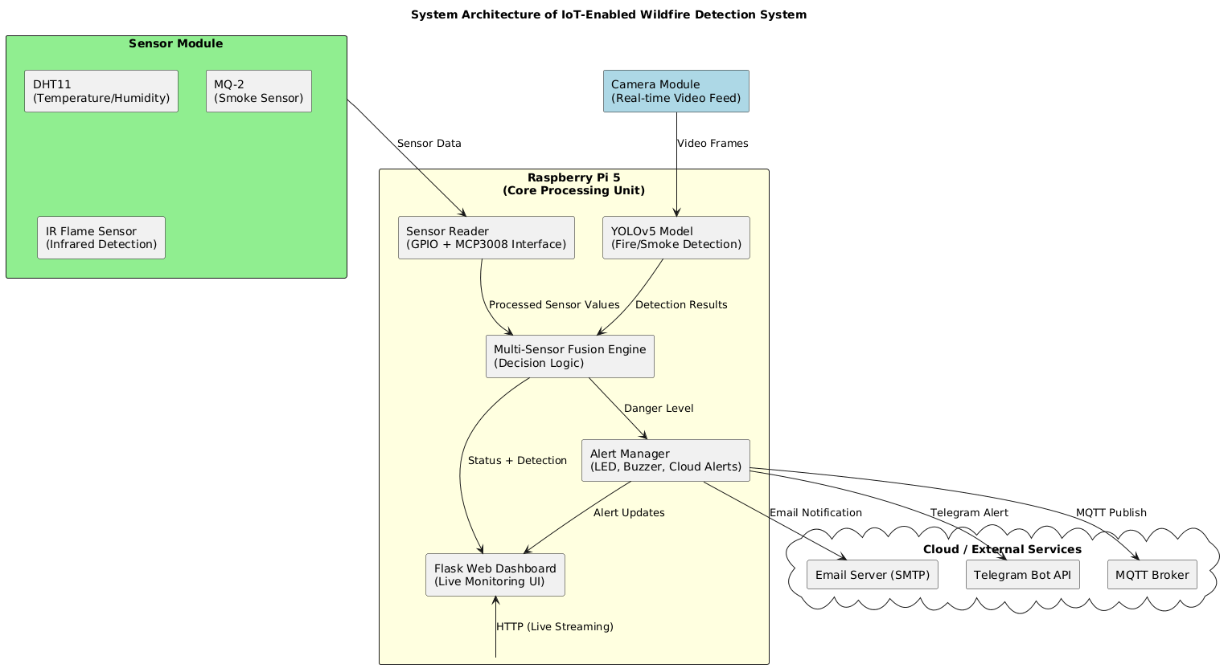
Figure 6.1.1 System architecture of the proposed IoT-enabled wildfire detection framework.
6.2 UML Diagrams
To ensure clarity and structured design, the system is modelled using the six essential UML diagrams:
6.2.1 Use Case Diagram
Purpose: Shows the interactions between the user and system functions.
Key Actors:
- System Administrator
- Monitoring Officer
- Raspberry Pi System
Main Use Cases:
- Start Detection
- View Live Dashboard
- Receive Alerts
- Access Sensor Data Logs
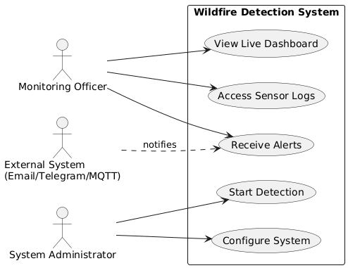
Figure 6.2.1.1 Use Case Diagram

6.2.2 Class Diagram
Purpose: Represents static structure and relationships among classes.
Key Classes and Attributes:
- CameraModule – init(), captureFrame()
- SensorModule – readDHT(), readMQ2(), readFlame()
- YOLOv5Detector – loadModel(), detect()
- FusionEngine – fuseData(), classifyAlert()
- AlertManager – sendEmail(), sendTelegram(), sendMQTT()
- Dashboard – updateLiveFeed(), displaySensors()
Relationships:
- Dashboard → FusionEngine (dependency)
- FusionEngine → Sensors & YOLOv5 (composition)
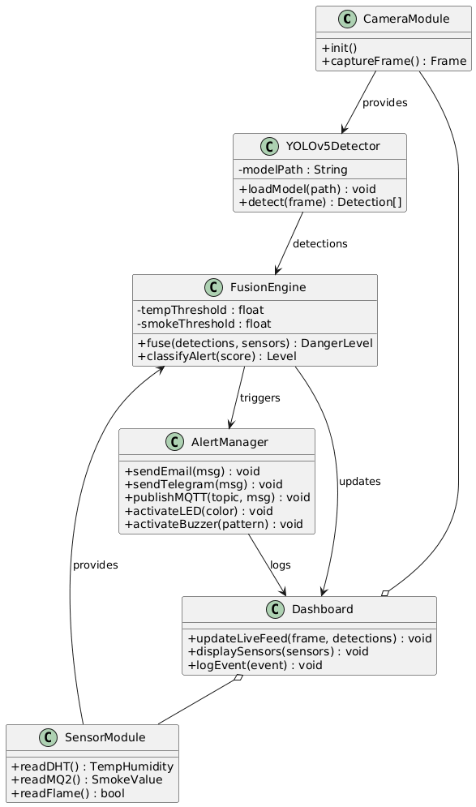
Figure 6.2.2.1 Class Diagram

6.2.3 Activity Diagram
Purpose: Describes system workflow.
Flow:
- Start
- Initialize all modules
- Capture frame
- YOLOv5 detection
- Read sensors
- Sensor + detection fusion
- Alert classification
- Trigger LEDs/Buzzer
- Send notifications
- Update dashboard
- Loop back to Step 3
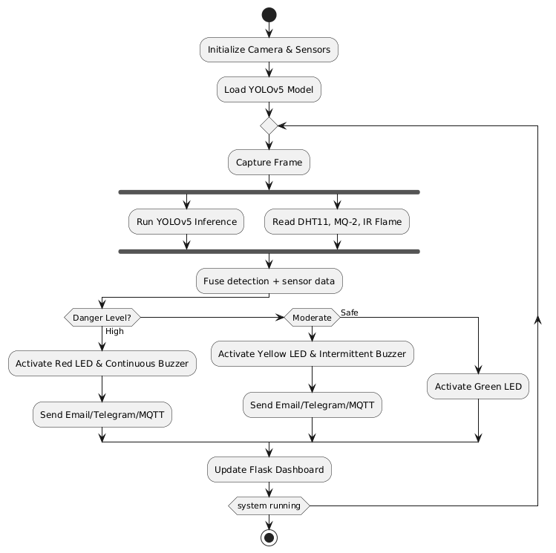
Figure 6.2.3.1 Activity Diagram

6.2.4 Sequence Diagram
Actors:
- User
- Dashboard
- Raspberry Pi
- YOLOv5 Model
- Sensor Module
- Alert Manager
Sequence Flow:
- User accesses dashboard
- Camera sends frame → YOLOv5 → detection
- Sensors → send readings
- FusionEngine → makes decision
- AlertManager → sends alerts
- Dashboard → updates UI
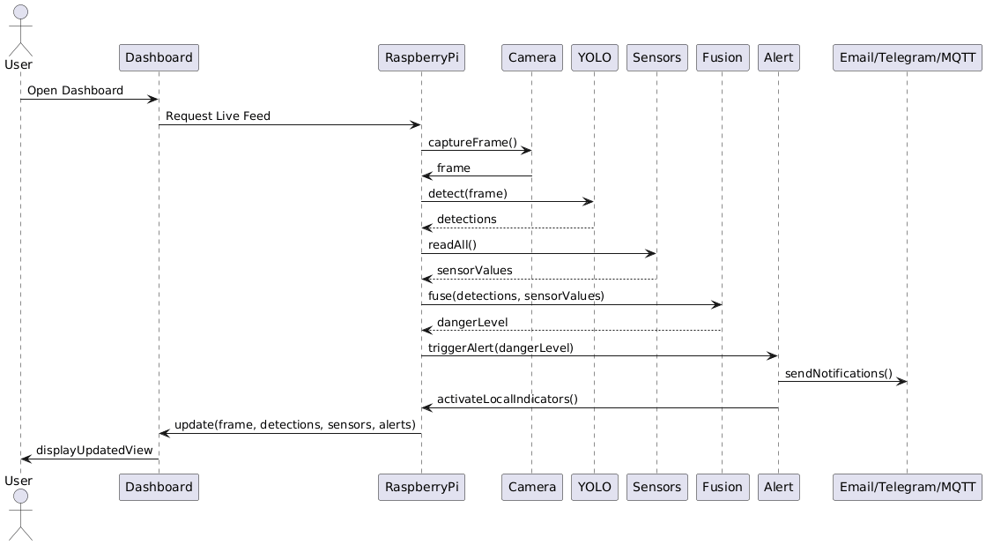
Figure 6.2.4.1 Sequence Diagram

6.2.5 Deployment Diagram
Nodes:
- Raspberry Pi 5
- Cloud Services (Email/Telegram/MQTT)
- Client Device (mobile/PC)
Artifacts Deployed:
- YOLOv5 model
- Flask web application
- GPIO sensor drivers
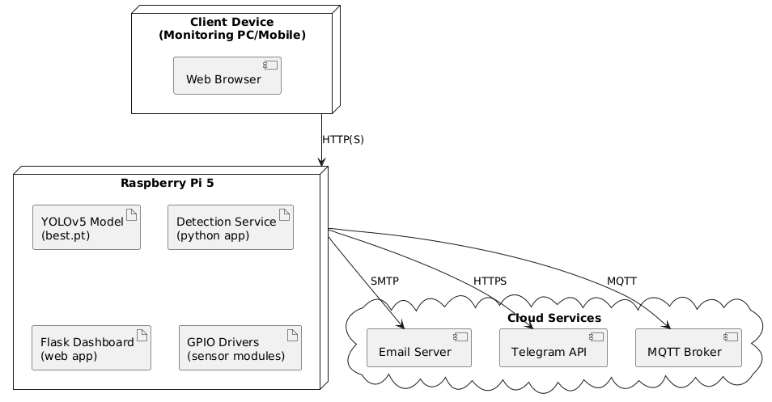
Figure 6.2.5 Deployment Diagram

6.2.6 Component Diagram
Components:
- YOLOv5 Detection Component
- Sensor Interface Component
- Fusion Engine Component
- Alert Component
- Dashboard Component
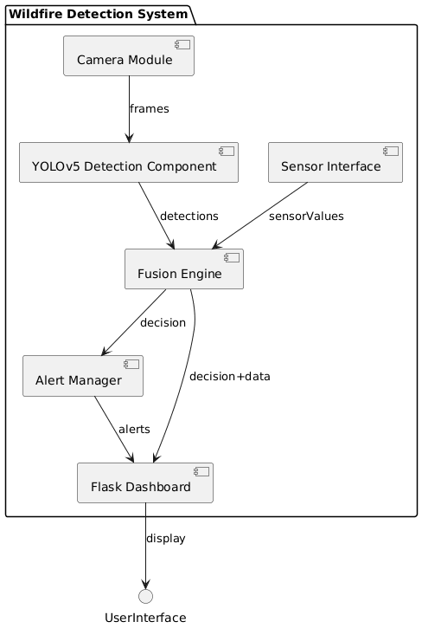
Figure 6.2.6 Component Diagram

CONCLUSION
Capability profiling and optimization of Vehicle On-Board Units (OBUs) play a critical role in enhancing the performance, efficiency, and reliability of modern intelligent transportation systems. As vehicles increasingly rely on real-time communication, sensor integration, and edge computing, OBUs must be capable of delivering consistent processing power while maintaining minimal latency, energy efficiency, and secure data handling. Through systematic capability profiling, performance gaps—such as processing bottlenecks, memory constraints, communication delays, and computational load distributions—can be accurately identified.
Optimization techniques such as task offloading, adaptive resource allocation, hardware acceleration, and software-level tuning significantly improve the operational efficiency of OBUs. These strategies enable OBUs to support advanced applications including V2X communication, autonomous driving assistance, real-time navigation, predictive maintenance, and over-the-air updates. The result is a more scalable and future-ready platform capable of supporting emerging automotive standards and communication protocols.
Overall, capability profiling combined with targeted optimization ensures that OBUs evolve from simple communication modules into powerful, intelligent edge processors. This not only enhances vehicle safety and connectivity but also contributes to the broader vision of seamless, secure, and efficient smart mobility ecosystems.

REFERENCES

[1] Shankar R, Marco J, Assadian F. The Novel Application of Optimization and Charge Blended Energy Management Control for Component Downsizing within a Plug‐in Hybrid Electric Vehicle. Energies. 2012; 5(12):4892-4923. https://doi.org/10.3390/en5124892
[2] Jiménez F, Cabrera-Montiel W. System for Road Vehicle Energy Optimization Using Real-Time Road and Traffic Information. Energies. 2014; 7(6):3576-3598. https://doi.org/10.3390/en7063576
[3] Wang S, Tao F, Shi Y, Wen H. Optimization of Vehicle Routing Problem with Time Windows for Cold Chain Logistics Based on Carbon Tax. Sustainability. 2017; 9(5):694. https://doi.org/10.3390/su9050694
[4] Levermore T, Sahinkaya MN, Zweiri Y, Neaves B. Real-Time Velocity Optimization to Minimize Energy Use in Passenger Vehicles. Energies. 2017; 10(1):30. https://doi.org/10.3390/en10010030
[5] Hur D-J, Jeong S-H, Song S-I, Noh J-H. Optimization Based on Product and Desirability Functions for Flow Distribution in Multi-Channel Cooling Systems of Power Inverters in Electric Vehicles. Applied Sciences. 2019; 9(22):4844. https://doi.org/10.3390/app9224844
[6] Kent T, Pipe A, Richards A, Hutchinson J, Schuster W. A Connected Autonomous Vehicle Testbed: Capabilities, Experimental Processes and Lessons Learned. Automation. 2020; 1(1):17-32. https://doi.org/10.3390/automation1010002
[7] Baz A, Yi P, Qurashi A. Intersection Control and Delay Optimization for Autonomous Vehicle Flows Only as Well as Mixed Flows with Ordinary Vehicles. Vehicles. 2020; 2(3):523-541. https://doi.org/10.3390/vehicles2030029
[8] Shokravi H, Shokravi H, Bakhary N, Heidarrezaei M, Rahimian Koloor SS, Petrů M. A Review on Vehicle Classification and Potential Use of Smart Vehicle-Assisted Techniques. Sensors. 2020; 20(11):3274. https://doi.org/10.3390/s20113274
[9] Zhu Y, et al. Vehicles OBU Computation Capability (VOCC) Dataset. Mendeley Data, V1, 2020. DOI: 10.17632/6fxbcs3hck.1
[10] Vo-Duy T, Ta MC, Nguyễn B-H, Trovão JPF. Experimental Platform for Evaluation of On-Board Real-Time Motion Controllers for Electric Vehicles. Energies. 2020; 13(23):6448. https://doi.org/10.3390/en13236448
[11] Xu N, Li X, Liu Q, Zhao D. An Overview of Eco-Driving Theory, Capability Evaluation, and Training Applications. Sensors. 2021; 21(19):6547. https://doi.org/10.3390/s21196547
[12] Ghoul T, Sayed T. Real-Time Safety Optimization of Connected Vehicle Trajectories Using Reinforcement Learning. Sensors. 2021; 21(11):3864. https://doi.org/10.3390/s21113864
[13] Ameen HA, Mahamad AK, Saon S, Malik RQ, Kareem ZH, Ahmadon MA Bin, Yamaguchi S. Identification of Driving Safety Profiles in Vehicle-to-Vehicle Communication System Based on Vehicle OBD Information. Information. 2021; 12(5):194. https://doi.org/10.3390/info12050194
[14] Shan D, Lei T, Yin X, Luo Q, Gong L. Extracting Key Traffic Parameters from UAV Video with On-Board Vehicle Data Validation. Sensors. 2021; 21(16):5620. https://doi.org/10.3390/s21165620
[15] Bethaz P, Cavaglion S, Cricelli S, Liore E, Manfredi E, Salio S, Regalia A, Conicella F, Greco S, Cerquitelli T. Empowering Commercial Vehicles through Data-Driven Methodologies. Electronics. 2021; 10(19):2381. https://doi.org/10.3390/electronics10192381
[16] Bučko B, Michálek M, Papierniková K, Zábovská K. Smart Mobility and Aspects of Vehicle-to-Infrastructure: A Data Viewpoint. Applied Sciences. 2021; 11(22):10514. https://doi.org/10.3390/app112210514
[17] Yu G, Liu S, Shangguan Q. Optimization and Evaluation of Platooning Car-Following Models in a Connected Vehicle Environment. Sustainability. 2021; 13(6):3474. https://doi.org/10.3390/su13063474
[18] Chen Y, Sun R, Wu X. Estimating Bounds of Aerodynamic, Mass, and Auxiliary Load Impacts on Autonomous Vehicles: A Powertrain Simulation Approach. Sustainability. 2021; 13(22):12405. https://doi.org/10.3390/su132212405
[19] Adelantado F, Ammouriova M, Herrera E, Juan AA, Shinde SS, Tarchi D. Internet of Vehicles and Real-Time Optimization Algorithms: Concepts for Vehicle Networking in Smart Cities. Vehicles. 2022; 4(4):1223-1245. https://doi.org/10.3390/vehicles4040065
[20] Pusztai Z, Kőrös P, Szauter F, Friedler F. Vehicle Model-Based Driving Strategy Optimization for Lightweight Vehicle. Energies. 2022; 15(10):3631. https://doi.org/10.3390/en15103631
[21] Al-Saadi M, Mathes M, Käsgen J, Robert K, Mayrock M, Mierlo JV, Berecibar M. Optimization and Analysis of Electric Vehicle Operation with Fast-Charging Technologies. World Electric Vehicle Journal. 2022; 13(1):20. https://doi.org/10.3390/wevj13010020
[22] Guerna A, Bitam S, Calafate CT. Roadside Unit Deployment in Internet of Vehicles Systems: A Survey. Sensors. 2022; 22(9):3190. https://doi.org/10.3390/s22093190
[23] Olariu S. Vehicular Crowdsourcing for Congestion Support in Smart Cities. Smart Cities. 2021; 4(2):662-685. https://doi.org/10.3390/smartcities4020034
[24] Pérez W, Tulpule P, Midlam-Mohler S, Rizzoni G. Data-Driven Adaptive Equivalent Consumption Minimization Strategy for Hybrid Electric and Connected Vehicles. Applied Sciences. 2022; 12(5):2705. https://doi.org/10.3390/app12052705
[25] Hanzl J, Pečman J, Bartuška L, Stopka O, Šarkan B. Research on the Effect of Road Height Profile on Fuel Consumption during Vehicle Acceleration. Technologies. 2022; 10(6):128. https://doi.org/10.3390/technologies10060128
[26] Croce AI, Musolino G, Rindone C, Vitetta A. Traffic and Energy Consumption Modelling of Electric Vehicles: Parameter Updating from Floating and Probe Vehicle Data. Energies. 2022; 15(1):82. https://doi.org/10.3390/en15010082
[27] Diachuk M, Easa SM. Improved Technique for Autonomous Vehicle Motion Planning Based on Integral Constraints and Sequential Optimization. Vehicles. 2022; 4(4):1122-1157. https://doi.org/10.3390/vehicles4040060
[28] Cai L, Zhang Q, Dai N, Xu Q, Gao L, Shang B, Xiang L, Chen H. Optimization of Control Strategy for Orderly Charging of Electric Vehicles in Mountainous Cities. World Electric Vehicle Journal. 2022; 13(10):195. https://doi.org/10.3390/wevj13100195
[29] Erdelić T, Carić T. Goods Delivery with Electric Vehicles: Electric Vehicle Routing Optimization with Time Windows and Partial or Full Recharge. Energies. 2022; 15(1):285. https://doi.org/10.3390/en15010285
[30] Ravi SS, Aziz M. Utilization of Electric Vehicles for Vehicle-to-Grid Services: Progress and Perspectives. Energies. 2022; 15(2):589. https://doi.org/10.3390/en15020589
[31] Guan T, Han Y, Kang N, Tang N, Chen X, Wang S. An Overview of Vehicular Cybersecurity for Intelligent Connected Vehicles. Sustainability. 2022; 14(9):5211. https://doi.org/10.3390/su14095211
[32] Campos-Ferreira AE, Lozoya-Santos JdJ, Tudon-Martinez JC, Mendoza RAR, Vargas-Martínez A, Morales-Menendez R, Lozano D. Vehicle and Driver Monitoring System Using On-Board and Remote Sensors. Sensors. 2023; 23(2):814. https://doi.org/10.3390/s23020814
[33] Sadaf M, Iqbal Z, Javed AR, Saba I, Krichen M, Majeed S, Raza A. Connected and Automated Vehicles: Infrastructure, Applications, Security, Critical Challenges, and Future Aspects. Technologies. 2023; 11(5):117. https://doi.org/10.3390/technologies11050117
[34] Luo W, Li X, Hu J, Hu W. Modeling and Optimization of Connected and Automated Vehicle Platooning Cooperative Control with Measurement Errors. Sensors. 2023; 23(21):9006. https://doi.org/10.3390/s23219006
[35] Liu Y, Yao C, Guo C, Yang Z, Fu C. Energy-Saving Optimization for Electric Vehicles in Car-Following Scenarios Based on Model Predictive Control. World Electric Vehicle Journal. 2023; 14(2):42. https://doi.org/10.3390/wevj14020042
[36] Liu Z, Wang W, He J, Zhang J, Wang J, Li S, Sun Y, Ren X. A New Hybrid Algorithm for Vehicle Routing Optimization. Sustainability. 2023; 15(14):10982. https://doi.org/10.3390/su151410982
[37] Mohammadi M, Fajri P, Sabzehgar R, Harirchi F. Autonomous Electric Vehicle Route Optimization Considering Regenerative Braking Dynamic Low-Speed Boundary. Algorithms. 2023; 16(6):262. https://doi.org/10.3390/a16060262
[38] Zhang L, Lu Y, Chen N, Wang P, Kong W, Wang Q, Qin G, Mou Z. Optimization of Roadside Unit Deployment on Highways under the Evolution of Intelligent Connected-Vehicle Permeability. Sustainability. 2023; 15(14):11112. https://doi.org/10.3390/su151411112
[39] Aletras N, Doulgeris S, Samaras Z, Ntziachristos L. Comparative Assessment of Supervisory Control Algorithms for a Plug-In Hybrid Electric Vehicle. Energies. 2023; 16(3):1497. https://doi.org/10.3390/en16031497
[40] Alolaiwy M, Hawsawi T, Zohdy M, Kaur A, Louis S. Multi-Objective Routing Optimization in Electric and Flying Vehicles: A Genetic Algorithm Perspective. Applied Sciences. 2023; 13(18):10427. https://doi.org/10.3390/app131810427
[41] Shahbazi Z, Nowaczyk S. Enhancing Energy Efficiency in Connected Vehicles for Traffic Flow Optimization. Smart Cities. 2023; 6(5):2574-2592. https://doi.org/10.3390/smartcities6050116
[42] Tsoukas V, Boumpa E, Chioktour V, Kalafati M, Spathoulas G, Kakarountas A. Development of a Dynamically Adaptable Routing System for Data Analytics Insights in Logistic Services. Analytics. 2023; 2(2):328-345. https://doi.org/10.3390/analytics2020018
[43] Vasile I, Tudor E, Sburlan I-C, Matache M-G, Cristea M. Optimization of the Electronic Control Unit of Electric-Powered Agricultural Vehicles. World Electric Vehicle Journal. 2023; 14(10):267. https://doi.org/10.3390/wevj14100267
[44] Justin S, Saleh W, Lashin MMA, Albalawi HM. Design of Metaheuristic Optimization with Deep-Learning-Assisted Solar-Operated On-Board Smart Charging Station for Mass Transport Passenger Vehicle. Sustainability. 2023; 15(10):7845. https://doi.org/10.3390/su15107845
[45] Kumar M, Panda KP, Naayagi RT, Thakur R, Panda G. Comprehensive Review of Electric Vehicle Technology and Its Impacts: Detailed Investigation of Charging Infrastructure, Power Management, and Control Techniques. Applied Sciences. 2023; 13(15):8919. https://doi.org/10.3390/app13158919
[46] Wei L, Liang L, Lei T, Yin X, Wang Y, Gao M, Liu Y. On-Board Unit (OBU)-Supported Longitudinal Driving Behavior Monitoring Using Machine Learning Approaches. Sensors. 2023; 23(15):6708. https://doi.org/10.3390/s23156708
[47] Ali WA, Fanti MP, Roccotelli M, Ranieri L. A Review of Digital Twin Technology for Electric and Autonomous Vehicles. Applied Sciences. 2023; 13(10):5871. https://doi.org/10.3390/app13105871
[48] Xu H, Zhang N, Li Z, Zhuo Z, Zhang Y, Zhang Y, Ding H. Energy-Saving Speed Planning for Electric Vehicles Based on RHRL in Car-Following Scenarios. Sustainability. 2023; 15(22):15947. https://doi.org/10.3390/su152215947
[49] Hermann D, Brousek J, Nemecek P. Method for the Conceptual Design of a New Mode of Urban Delivery Vehicle. World Electric Vehicle Journal. 2023; 14(12):323. https://doi.org/10.3390/wevj14120323
[50] Chauhan V, Chang C-M, Javanmardi E, Nakazato J, Lin P, Igarashi T, Tsukada M. Fostering Fuzzy Logic in Enhancing Pedestrian Safety: Harnessing Smart Pole Interaction Unit for Autonomous Vehicle-to-Pedestrian Communication and Decision Optimization. Electronics. 2023; 12(20):4207. https://doi.org/10.3390/electronics12204207
[51] Pires TR, Fernandes JFP, Branco PJC. Driving Profile Optimization for Energy Management in the Formula Student Técnico Prototype. Energies. 2024; 17(24):6313. https://doi.org/10.3390/en17246313
[52] Zhang C, Ji M, Wu Q, Fan P, Fan Q. Optimizing Age of Information in Internet of Vehicles over Error-Prone Channels. Sensors. 2024; 24(24):7888. https://doi.org/10.3390/s24247888
[53] Wang P, Ouyang T, Zhao S, Wang X, Ni Z, Fan Y. Intelligent Vehicle Formation System Based on Information Interaction. World Electric Vehicle Journal. 2024; 15(6):252. https://doi.org/10.3390/wevj15060252
[54] Garikapati D, Shetiya SS. Autonomous Vehicles: Evolution of Artificial Intelligence and the Current Industry Landscape. Big Data and Cognitive Computing. 2024; 8(4):42. https://doi.org/10.3390/bdcc8040042
[55] Al-refai G, Al-refai M, Alzu’bi A. Driving Style and Traffic Prediction with Artificial Neural Networks Using On-Board Diagnostics and Smartphone Sensors. Applied Sciences. 2024; 14(12):5008. https://doi.org/10.3390/app14125008
[56] Romero CA, Correa P, Ariza Echeverri EA, Vergara D. Strategies for Reducing Automobile Fuel Consumption. Applied Sciences. 2024; 14(2):910. https://doi.org/10.3390/app14020910
[57] Khanmohamadi M, Guerrieri M. Advanced Sensor Technologies in CAVs for Traditional and Smart Road Condition Monitoring: A Review. Sustainability. 2024; 16(19):8336. https://doi.org/10.3390/su16198336
[58] Wen J, Li L, Wu Q, Li K, Lu J. Multi-Objective Cooperative Adaptive Cruise Control Platooning of Intelligent Connected Commercial Vehicles in Event-Triggered Conditions. Actuators. 2024; 13(12):522. https://doi.org/10.3390/act13120522
[59] Zhang Q, Ikram M, Xu K. Online Optimization of Vehicle-to-Grid Scheduling to Mitigate Battery Aging. Energies. 2024; 17(7):1681. https://doi.org/10.3390/en17071681
[60] Rosero F, Rosero CX, Segovia C. Towards Simpler Approaches for Assessing Fuel Efficiency and CO₂ Emissions of Vehicle Engines in Real Traffic Conditions Using On-Board Diagnostic Data. Energies. 2024; 17(19):4814. https://doi.org/10.3390/en17194814
[61] Visconti P, Rausa G, Del-Valle-Soto C, Velázquez R, Cafagna D, De Fazio R. Innovative Driver Monitoring Systems and On-Board-Vehicle Devices in a Smart-Road Scenario Based on the Internet of Vehicle Paradigm: A Literature and Commercial Solutions Overview. Sensors. 2025; 25(2):562. https://doi.org/10.3390/s25020562
[62] Mansouri N, Mnassri A, Nasri S, Ali M, Lashab A, Vasquez JC, Guerrero JM. Control and Optimization of Hydrogen Hybrid Electric Vehicles Using GPS-Based Speed Estimation. Electronics. 2025; 14(1):110. https://doi.org/10.3390/electronics14010110
[63] Wang T, Qu D. Dynamic Stability Analysis and Optimization of Multi-Vehicle Systems in Heterogeneous Connected Traffic. Sensors. 2025; 25(3):727. https://doi.org/10.3390/s25030727
[64] Bilban M, İnan O. Optimizing Autonomous Vehicle Performance Using Improved Proximal Policy Optimization. Sensors. 2025; 25(6):1941. https://doi.org/10.3390/s25061941
[65] Zhang B, Shen G, Wang Y, Zhang Y, Zhang C, Wang X, Liu Z, Luo X. Multi-Objective Optimization of Speed Profile for Railway Catenary Maintenance Vehicle Operations Based on Improved Non-Dominated Sorting Genetic Algorithm III. Applied Sciences. 2025; 15(8):4361. https://doi.org/10.3390/app15084361
[66] Wang X, Chen T, Wang R, Lu J, Dou G. Review of State Estimation Methods for Autonomous Ground Vehicles: Perspectives on Estimation Objects, Vehicle Characteristics, and Key Algorithms. Sensors. 2025; 25(13):3927. https://doi.org/10.3390/s25133927
[67] Wang D, Zheng W, Zhou H. Robust Optimization for Electric Vehicle Routing Problem Considering Time Windows Under Energy Consumption Uncertainty. Applied Sciences. 2025; 15(2):761. https://doi.org/10.3390/app15020761
[68] Cao H, Zhao J. Optimizing Modular Vehicle Public Transportation Services with Short-Turning Strategy and Decoupling/Coupling Operations. Sustainability. 2025; 17(3):870. https://doi.org/10.3390/su17030870
[69] Husyeva II, Navas-Delgado I, García-Nieto J. Data-Driven Approaches for Efficient Vehicle Driving Analysis: A Survey. Journal of Sensor and Actuator Networks. 2025; 14(3):52. https://doi.org/10.3390/jsan14030052
[70] Arslan M, Karamangil Mİ. Comprehensive Optimization and Design of an Electric Vehicle Battery Box Side Profile for Lightweight and Crashworthiness Using a Novel Hybrid Structure. Applied Sciences. 2025; 15(4):2037. https://doi.org/10.3390/app15042037
[71] Palamutçuoğlu BT, Çavuşoğlu S, Çamlı AY, Virlanuta FO, Bacalum S, Züngün D, Moisescu F. Solution of the Capacity-Constrained Vehicle Routing Problem Considering Carbon Footprint Within the Scope of Sustainable Logistics with Genetic Algorithm. Sustainability. 2025; 17(2):727. https://doi.org/10.3390/su17020727
[72] Almutairi A, Owais M. Reliable Vehicle Routing Problem Using Traffic Sensors Augmented Information. Sensors. 2025; 25(7):2262. https://doi.org/10.3390/s25072262
[73] Youssef B. A Robust Adaptive Strategy for Diesel Particulate Filter Health Monitoring Using Soot Sensor Data. Vehicles. 2025; 7(2):39. https://doi.org/10.3390/vehicles7020039
[74] Šarkan B, Loman M, Caban J, Malek A, Richtář M, Stopková M. Changing Fuel Consumption Data in Official Vehicle Documents—Case Study in the Slovak Republic. Vehicles. 2025; 7(1):27. https://doi.org/10.3390/vehicles7010027
[75] Dafhalla AKY, Ahmed AET, Sid Ahmed NMO, Filali A, Alhomed LS, Ali FAE, Eldeen AIG, Elobaid ME, Adam T. High-Performance Data Throughput Analysis in Wireless Ad Hoc Networks for Smart Vehicle Interconnection. Computers. 2025; 14(2):56. https://doi.org/10.3390/computers14020056
[76] Kavitha C, Gautam G, Sudeep R, Kannan C, Ashok B. Hybrid Vehicle Battery Health State Estimation Based on Intelligent Regenerative Braking Control. World Electric Vehicle Journal. 2025; 16(5):280. https://doi.org/10.3390/wevj16050280
[77] Sardar SA, Iqbal S, Park J, Han S, Kim WY. Field Data Retrieval for Electric Vehicles and Estimating Equivalent Circuit Model Parameters via Particle Swarm Optimization. Technologies. 2025; 13(3):91. https://doi.org/10.3390/technologies13030091
[78] Dafhalla AKY, Isam HM, Ahmed AET, Ahmed IS, Alhomed LS, Zahou AMe, Ali FAE, Zayan DMI, Elobaid ME, Adam T. Performance Evaluation and QoS Optimization of Routing Protocols in Vehicular Communication Networks Under Delay-Sensitive Conditions. Computers. 2025; 14(7):285. https://doi.org/10.3390/computers14070285
[79] Nasri S, Mansouri N, Mnassri A, Lashab A, Vasquez J, Rezk H. Global Analysis of Electric Vehicle Charging Infrastructure and Sustainable Energy Sources Solutions. World Electric Vehicle Journal. 2025; 16(4):194. https://doi.org/10.3390/wevj16040194
[80] Kiani H, Vahidi B, Hosseinian SH, Lazaroiu GC, Siano P. Prospective Design and Evaluation of a Renewable Energy Hybrid System to Supply Electrical and Thermal Loads Simultaneously with an Electric Vehicle Charging Station for Different Weather Conditions in Iran. Smart Cities. 2025; 8(2):61. https://doi.org/10.3390/smartcities8020061

